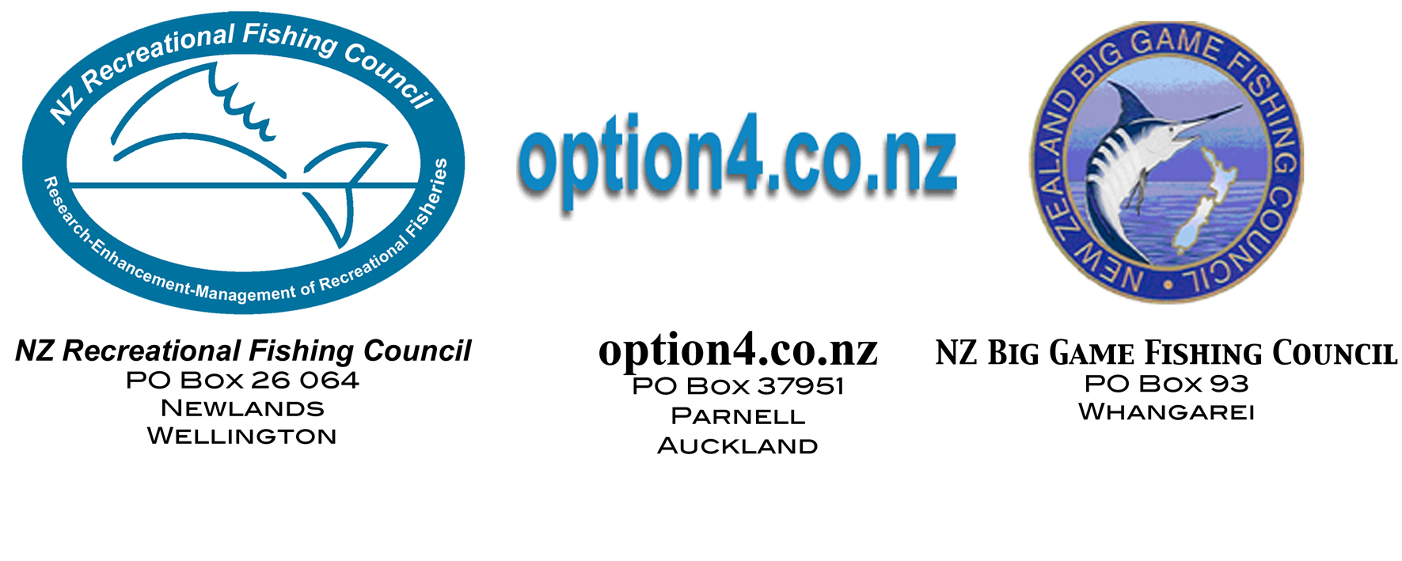

8/12/02
The Minister of Fisheries
Pete Hodgson
Parliament
Wellington

Dear Minister

The purpose of this letter is to advise you that there is complete consensus between NZRFC, NZBGFC and option4.co.nz on the following key recreational fisheries management principles. This consensus has existed for some time and is now formalised in this document.

- Principles developed during the Soundings process.
- Preference to non-commercial fishing as guaranteed by the cornerstone statement in the 1989 Recreational Fishing Policy.
- Need for legislative reform to implement the principles and preference statement and to ensure the public sector is adequately resourced to be an effective contributor to fisheries management.
- Rejection of the capped proportional share concept.
- The requirement for improved information.

These key points are discussed in more detail below.

1. Principles developed during the Soundings process

The principles are: -

- A priority right over commercial fishers for free access to a reasonable daily bag-limit to be written into legislation.
- The ability to exclude commercial methods that deplete recreationally important areas.
- The ability to devise plans to ensure future generations enjoy the same or better quality of rights while preventing fish conserved for recreational use being given to the commercial sector.
- No licensing of recreational fishers.

These principles have been policy of the NZRFC for many years and were reaffirmed at their AGM in July 2001.This endorsement took place at the annual general meeting. Ministry of Fisheries staff witnessed this process of arriving at consensus. NZBGFC have also endorsed these principles, as have option 4. We note to date that only one of these principles has been adopted by Government with your clear statement that there will be no licensing of recreational fishers.

2. Cornerstone statement in the 1989 Recreational Fishing Policy
The “cornerstone statement” in the 1989 Recreational Fishing Policy, signed off by the senior Labour Party Minister, the Hon Colin Moyle, states: -

“The cornerstone of the policy is presented in the first national objective: to ensure recreational users have access to a reasonable share of fishery resources. Government's position is clear, where a species of fish is not sufficiently abundant to support both commercial and non-commercial fishing, preference will be given to non-commercial fishing. This position reflects Government's resolve to ensure all New Zealanders can enjoy and benefit from our fisheries.”

All three organisations are unanimous and consistent in their endorsement of the 1989 Policy, and the Ministers forward in the form of his formal letter of introduction and release and the cornerstone statement contained in the 4th paragraph, now known as the “Moyle Promise”. This very important policy document is still very much alive. It has never been repealed by any subsequent Government, or the Ministry. It was however ignored by the National Government and the Ministry during the 1990s.

To the recreational sector, the 1989 Policy is the equivalent of the Treaty of Waitangi to Maori. For many years, neither recreational/sustenance nor the Maori sectors were recognised by the Ministry. The recreational sector will not rest until the statement confirming preference to non-commercial fishing (as stated by the Minister in the 1989 Policy) is recognised by Government.

3. Need for Legislative reform
All three organisations have agreed on the need for legislative reform and for the defining of the public’s right in the legislation. We are open to further discussion on how this can be achieved but before firming views and policies we have awaited the occasional papers and legal documents that were promised in the paper “Recreational Fishing Reform: Action Plan 2002-03” released by the Ministry in January 2002. In that paper it was stated:

“Phase one: February - July 2002
Occasional Papers and Seminars
The consultation processes to date have identified some issues of concern to stakeholders and the Cabinet has outlined some constraints and objectives of future policy development. In order to address these issues and concerns MFish will commission papers on the issues of most concern. Where demand exists, seminars can be held discussing the papers with stakeholders. MFish can provide experts to speak where this is beneficial. These meetings will consist of a presentation followed by discussion and consideration of different viewpoints on the issue at hand.
Suggested topics include:
- The Treaty of Waitangi and the Fisheries Settlement Act and their implications for fisheries management
- International obligations, common law rights and related issues
- Property rights and their application to natural resource management including the QMS and the management of commercial fisheries under the Fisheries Act.
- Environmental objectives of government including the Fisheries Act and the Marine Reserves Act
Given that there are stakeholders around the country and participation can be expensive, seminars will be held in the regions and only where a demand is demonstrated. Seminars can be tailored to the concerns of different regions and scheduled in consultation with stakeholders.
The objectives of this phase are to foster a broad understanding of how options might meet the objectives and constraints that cabinet has set for the development of options for reform. It will also serve to make information available on the broader policy environment. MFish encourages people to take advantage of experts and papers that we provide and to this end MFish will publish the papers on it's website.
MFish will be happy to consider proposals for incorporation into the policy development process from stakeholders at any time during this phase (prior to the formal input in the consultation phase). Options will need to address the objectives that government has identified and to be achievable within the constraints that have been set.”
Given that it is now December we wonder where these papers and seminars are. To our knowledge none have been issued nor any seminars held. We ask, why have the Ministry not yet delivered these documents and when will they? Is it now the intention of you as Minister and your Ministry to just present the sector with a fait accompli for consultation on the Governments preferred option?

4. Rejection of the proportional share concept
The recreational sector has, and always will, totally and unanimously reject a capped proportional share concept because of the Moyle Promise referred to above. We accept that management of fisheries will continue under the QMS but this needs to reflect the public right of access and priority.

We reject capped proportionalism because the fish in the sea are a public resource, and the public right to be able to expect to catch a reasonable number of fish on a fishing trip must come before commercial interests within the requirements of a sustainable fishery. The surplus should be available to the commercial sector once they have paid the Crown for the access right to generate revenue from a public resource. We reject any agenda to cap the recreational catch in order to preserve some “ fixed/defined proportion” of the TAC for commercial concerns. As the High Court stated in the judgement on SNA 1 (CA82/97) “If over time a greater recreational demand arises it would be strange if the Minister was precluded by some proportional rule from giving some extra allowance to cover it, subject always to his obligation carefully to weigh all the competing demands on the TAC before deciding how much should be allocated to each interest group.”

5. Improved Information

It is agreed that a fundamental element of sustainable fisheries management is to ensure that management decisions are based on accurate estimates of all sector’s catches. The disparity between recent estimates of recreational harvest and the historical recreational harvest estimates that have been used for fisheries management decision making to date, clearly indicate the need for more resources to be deployed to prevent errors of such magnitude occurring in the future. It is also agreed that better information regards “all other forms of fishing related mortality” by all sectors need to be developed.

Management
Until the rights of the public are clearly defined the public role in the management of New Zealand’s fisheries cannot be determined. If we are to become involved in management, surely we have to define what it is we will be managing.
We accept that the recreational sector needs to play its part in managing stock to sustainable levels and suggest there is already adequate evidence to that effect. The recreational MLS and reductions in bag limits in the past are examples of our resolve to support sustainability. At the same time the playing field has to be levelled and the public sector representative organisations need to be assured that adequate resourcing is available for the level of management responsibility that comes out of the rights definition process.

Conclusion
Minister, as indicated above, the purpose of this letter is to show to you that the recreational sector is in consensus on the recreational fishing reform process. We feel it entirely reasonable to expect to see some real effort put into the recreational reform process by you and your Ministry, as promised. Why have little or no resources been dedicated to furthering the public fishing rights definition process since the tabling of the Cabinet Paper in November 2001? Why are all MFish resources being used to address the needs of the commercial sector (new species into QMS and Aquaculture reforms to name a couple) while we stand and wait?

We look forward to your response. We would also appreciate receiving advice you might receive from your Ministry regards this correspondence.

We, the undersigned, remain yours in good faith,

Ross Gildon, President, NZRFC

Jeff Romerill, President, NZBGFC

Paul Barnes, Project Leader, option4.co.nz

